SOFTWARE REQUIREMENTS SPECIFICATION (SRS)
New Navnath Electronics & Electricals
E-Commerce & Service Booking Website
Project Version: 1.0
Date: 21 August 2026
Prepared By: Navnath Electronics Team

Document Control

Version | Date | Author | Description / Change
1.0 | 21-08-2026 | Navnath Electronics Team | Initial Draft

1. Introduction

1.1 Purpose
The purpose of this Software Requirements Specification is to define the functional and non-functional requirements of the New Navnath Electronics & Electricals E-Commerce & Service Booking Website.
The system is designed to provide customers with an online platform for browsing and purchasing electrical and electronic products, booking electrical services, managing orders, tracking service requests, maintaining user profiles, and contacting the business.
The system also provides an Admin Dashboard through which administrators can manage products, categories, orders, users, service requests, inventory, and business reports.
This SRS provides a detailed description of the system requirements that can be used for design, development, testing, deployment, and maintenance.

1.2 Scope
The system will provide the following major capabilities:

Customer/User Side
- Visit and browse the website.
- Browse electrical and electronic products.
- Search and filter products by category, brand, and price.
- View product details, specifications, prices, and reviews.
- Add products to cart.
- Add products to wishlist.
- Checkout and provide delivery details.
- Select payment method.
- Place orders.
- Receive order confirmation.
- Track orders through My Orders.
- Download invoices.
- Register and login.
- Manage user profile.
- Book electrical services.
- Submit service requests.
- Receive service confirmation.
- Track service requests.
- View service completion status.
- Contact the business.
- Send messages through contact form.
- Call or use WhatsApp for support.

Admin Side
- Secure admin login.
- View dashboard and analytics.
- Add, edit, and delete products.
- Update product prices.
- Manage product stock.
- Add, edit, and delete categories.
- View and manage orders.
- Accept or reject orders.
- Ship and deliver orders.
- Manage customers/users.
- View order history.
- Manage service requests.
- Accept or reject service requests.
- Mark services as completed.
- Generate/view sales and revenue reports.
- View best-selling products.
- Logout securely.
The workflow also specifies responsive design, dark mode, multiple payment methods, order tracking, invoice download, and live support as key features.

1.3 Definitions, Acronyms and Abbreviations
Term | Definition
SRS | Software Requirements Specification
Admin | Authorized person responsible for managing the website
Customer/User | Person who browses products, purchases products, or books services
E-Commerce | Online buying and selling of products
Service Request | Request submitted by a customer for an electrical service
COD | Cash on Delivery
UPI | Unified Payments Interface
UI | User Interface
API | Application Programming Interface
DB | Database
JWT | JSON Web Token
CRUD | Create, Read, Update, Delete
ERP | Enterprise Resource Planning
Invoice | Document containing order and payment information
Wishlist | List of products saved by a customer for future purchase

1.4 References
- Project workflow provided for New Navnath Electronics & Electricals.
- Software Requirements Specification template provided by the project team.
- React.js frontend framework.
- Node.js backend environment.
- MongoDB database.
- Razorpay payment gateway.
- Cloudinary image storage.
- Vercel/Render deployment environment.

1.5 Document Overview
This document describes the complete requirements of the New Navnath Electronics & Electricals website.
Section 1 introduces the project.
Section 2 describes the overall system, users, operating environment, constraints, assumptions, and major functions.
Section 3 defines the functional requirements.
Section 4 defines non-functional requirements.
Section 5 describes external interfaces.
Section 6 describes required system models and diagrams.
Section 7 describes data requirements.
Section 8 defines business rules.
Section 9 defines acceptance criteria.
Section 10 contains appendices and supporting information.

2. Overall Description

2.1 Product Perspective
The system is a web-based E-Commerce and Electrical Service Booking Platform.
The customer interacts with the website through a responsive web interface. Product, user, order, service, and category information is processed through the backend server and stored in the MongoDB database.
The workflow specifies the following technology stack:
- Frontend: React.js
- Backend: Node.js
- Database: MongoDB
- Payment: Razorpay
- Image Storage: Cloudinary
- Deployment: Vercel / Render
The system contains two primary flows:
- Customer Flow
- Admin Flow

Customer Flow
Visit Website → Browse Products/Services → Login/Register → Browse Products → Add to Cart → Checkout → Delivery Details → Payment → Place Order → Order Confirmation → Track Order → Order Delivered
For services:
View Service List → Select Service → Fill Booking Form → Submit Request → Service Confirmation → Technician Visit → Service Completed

Admin Flow
Admin Login → Admin Dashboard → Manage Products/Categories → Manage Orders/Users/Services → View Reports → Logout

2.2 Product Functions
The major functions of the system are:
- User registration and authentication.
- User login and logout.
- Product browsing.
- Product search and filtering.
- Product detail viewing.
- Shopping cart management.
- Wishlist management.
- Checkout.
- Delivery information management.
- Online/COD payment processing.
- Order placement.
- Order tracking.
- Invoice generation/download.
- Electrical service booking.
- Service request management.
- User profile management.
- Contact and support.
- Admin authentication.
- Product management.
- Category management.
- Inventory management.
- Order management.
- User/customer management.
- Service request management.
- Sales and revenue reporting.

2.3 User Classes and Characteristics

Customer
Customers use the website to purchase products and book services.
Expected capabilities:
- Basic web browsing knowledge.
- Ability to register/login.
- Ability to search and purchase products.
- Ability to submit service requests.

Administrator
Administrators manage the complete business operation through the Admin Dashboard.
Expected capabilities:
- Knowledge of product and inventory management.
- Ability to manage orders and service requests.
- Ability to manage customers.
- Ability to view business reports.

Technician/Service Personnel
The workflow indicates technician visits as part of the service process. The system records the service request and technician visit status.

2.4 Operating Environment

Client Environment
- Modern web browser.
- Desktop, laptop, tablet, or smartphone.
- Internet connection.
- Responsive web interface.

Server Environment
- Node.js backend.
- MongoDB database.
- Cloudinary image storage.
- Razorpay payment gateway.
- Vercel/Render deployment.

Frontend
- React.js.

2.5 Design and Implementation Constraints
- The system must use the specified technology stack.
- Payment processing depends on the Razorpay payment service.
- Image storage depends on Cloudinary.
- The application requires an active internet connection.
- Admin functions must be accessible only to authorized administrators.
- Customer information must be protected from unauthorized access.
- The website should support responsive layouts.
- Database operations depend on MongoDB availability.
- Third-party service availability may affect payment and image-related operations.

2.6 Assumptions and Dependencies

Assumptions
- Customers have access to the internet.
- Customers provide valid delivery and contact information.
- Admin users have valid administrative credentials.
- Product information is maintained by administrators.
- Service information is maintained by administrators.

Dependencies
- React.js
- Node.js
- MongoDB
- Razorpay
- Cloudinary
- Vercel/Render
- Internet connectivity

3. Functional Requirements
FR-001: User Registration
The system shall allow a new customer to create an account.
Field | Details
Priority | High
Preconditions | The customer does not already have an account.
Inputs | Required registration information such as user credentials and profile details.
Processing / Business Logic | The system shall validate the entered information and create a customer account.
Outputs | Successful registration confirmation.
Exceptions | Registration shall fail if required information is invalid or the account already exists.
Acceptance Criteria | A valid customer shall be able to successfully create an account and subsequently log in.
Dependencies | Backend authentication and database.

FR-002: User Login
The system shall allow registered customers to log in.
Field | Details
Priority | High
Preconditions | A valid customer account exists.
Inputs | Login credentials.
Processing / Business Logic | The system shall validate the credentials.
Outputs | Authenticated customer session and access to user features.
Exceptions | Invalid credentials shall generate an appropriate error.
Acceptance Criteria | Only users with valid credentials shall gain access to their account.
Dependencies | Authentication system and database.

FR-003: Browse Products
The system shall display available electrical and electronic products.
Field | Details
Priority | High
Inputs | Customer navigation request.
Processing / Business Logic | The system shall retrieve available products from the database.
Outputs | Product listing.
Acceptance Criteria | Available products shall be displayed with relevant product information.

FR-004: Search and Filter Products
The system shall allow customers to search and filter products.
Field | Details
Priority | High
Inputs | Search keyword, category, brand, and price.
Processing / Business Logic | The system shall filter matching products.
Outputs | Filtered product list.
Acceptance Criteria | The system shall display products matching the selected search/filter conditions.

FR-005: View Product Details
The system shall display detailed information about a selected product.
Field | Details
Priority | High
Inputs | Selected product.
Outputs | Product specifications, price, reviews, and related information.
Acceptance Criteria | The customer shall be able to view complete available details of a product.

FR-006: Shopping Cart
The system shall allow customers to add products to a shopping cart.
Field | Details
Priority | High
Inputs | Product and quantity.
Processing / Business Logic | The system shall add the selected product to the customer's cart.
Outputs | Updated cart.
Acceptance Criteria | Selected products shall appear in the cart with applicable quantities and prices.

FR-007: Wishlist
The system shall allow customers to save products to a wishlist.
Field | Details
Priority | Medium
Inputs | Selected product.
Processing / Business Logic | The system shall associate the product with the customer's wishlist.
Outputs | Updated wishlist.
Acceptance Criteria | The customer shall be able to add and view wishlist products.

FR-008: Checkout
The system shall provide a checkout process for selected products.
Field | Details
Priority | High
Preconditions | The cart contains at least one product.
Inputs | Cart details and delivery information.
Processing / Business Logic | The system shall calculate the order amount and prepare the order for payment.
Outputs | Checkout summary.
Acceptance Criteria | The customer shall be able to proceed from cart to checkout successfully.

FR-009: Delivery Details
The system shall collect customer delivery information.
Field | Details
Priority | High
Inputs | Name, address, phone number, and other required delivery details.
Processing / Business Logic | The system shall validate and associate the information with the order.
Outputs | Saved delivery information.
Acceptance Criteria | An order cannot be placed without valid required delivery details.

FR-010: Payment Processing
The system shall support multiple payment methods shown in the workflow, including COD, UPI, and card/online payment through Razorpay.
Field | Details
Priority | High
Inputs | Payment method and required payment information.
Processing / Business Logic | The system shall process the selected payment method.
Outputs | Payment success/failure status.
Exceptions | Failed payments shall not result in an incorrectly confirmed paid order.
Acceptance Criteria | A successful payment shall generate a corresponding payment status for the order.
Dependencies | Razorpay/payment infrastructure.

FR-011: Place Order
The system shall allow customers to place an order after completing checkout.
Field | Details
Priority | High
Inputs | Cart, delivery details, and payment information.
Processing / Business Logic | The system shall create an order record.
Outputs | Order confirmation and Order ID.
Acceptance Criteria | A valid order shall be stored and displayed in the customer's order history.

FR-012: Order Confirmation
The system shall provide confirmation after successful order placement.
Field | Details
Priority | High
Outputs | Order ID and invoice/order information.
Acceptance Criteria | The customer shall receive confirmation containing the relevant order information.

FR-013: Order Tracking
The system shall allow customers to track orders through My Orders.
Field | Details
Priority | High
Inputs | Authenticated customer account.
Processing / Business Logic | The system shall retrieve order status.
Outputs | Current order status.
Acceptance Criteria | The customer shall be able to view the current status of their order.

FR-014: Invoice Download
The system shall allow customers to download/view the invoice associated with an order.
Field | Details
Priority | Medium
Preconditions | An order exists.
Outputs | Order invoice.
Acceptance Criteria | The customer shall be able to access the invoice for an eligible order.

FR-015: Service Listing
The system shall display available electrical services.
Field | Details
Priority | High
Outputs | Service list.
Acceptance Criteria | Customers shall be able to view available services.

FR-016: Service Selection
The system shall allow customers to select a required electrical service such as repair or installation.
Field | Details
Priority | High
Inputs | Selected service.
Outputs | Selected service displayed in the booking process.

FR-017: Service Booking
The system shall provide a service booking form.
Field | Details
Priority | High
Inputs | Customer name, phone number, address, selected service, and preferred date.
Processing / Business Logic | The system shall validate the information and create a service request.
Outputs | Submitted service request.
Acceptance Criteria | A valid service request shall be successfully stored in the system.

FR-018: Service Confirmation
The system shall provide confirmation after a service request is submitted.
Field | Details
Priority | High
Outputs | Service request confirmation.
Acceptance Criteria | The customer shall receive confirmation that the service request has been submitted.

FR-019: Technician Visit
The system shall maintain the service workflow from request submission to technician visit and completion.
Field | Details
Priority | High
Processing / Business Logic | The service request status shall progress according to the service process.
Outputs | Updated service status.
Acceptance Criteria | The service request shall be capable of progressing to technician visit and completed status.

FR-020: User Profile
The system shall provide a profile section for authenticated customers.
Field | Details
Priority | Medium
Outputs | Customer profile information.
Acceptance Criteria | An authenticated customer shall be able to access their profile.

FR-021: Contact and Support
The system shall provide contact options including address/map, contact form, phone call, WhatsApp, and quick support.
Field | Details
Priority | Medium
Inputs | Customer message or contact action.
Outputs | Contact/support request or communication channel.
Acceptance Criteria | Customers shall be able to access the available contact/support options.

Admin Functional Requirements
FR-022: Admin Login
The system shall provide secure login for administrators.
Field | Details
Priority | High
Inputs | Admin credentials.
Processing / Business Logic | The system shall authenticate the administrator.
Outputs | Admin Dashboard access.
Acceptance Criteria | Only authorized administrators shall access administrative functions.

FR-023: Admin Dashboard
The system shall provide an Admin Dashboard containing an overview and analytics.
Field | Details
Priority | High
Outputs | Business overview and relevant analytics.
Acceptance Criteria | An authenticated admin shall be able to access the dashboard.

FR-024: Product Management
The admin shall be able to add, edit, and delete products.
Field | Details
Priority | High
Inputs | Product information.
Processing / Business Logic | The system shall create, update, or remove product records.
Outputs | Updated product catalogue.
Acceptance Criteria | Changes made by the admin shall be reflected in the product catalogue.

FR-025: Price and Stock Management
The admin shall be able to update product prices and manage stock.
Field | Details
Priority | High
Inputs | Product price and stock information.
Outputs | Updated product inventory information.
Acceptance Criteria | Updated price and stock values shall be reflected in the system.

FR-026: Category Management
The admin shall be able to add, edit, and delete product categories.
Field | Details
Priority | High
Acceptance Criteria | Authorized administrators shall be able to maintain categories.

FR-027: Order Management
The admin shall be able to view and manage customer orders. Functions: view orders, accept orders, reject orders, ship orders, manage delivery status.
Field | Details
Priority | High
Acceptance Criteria | The admin shall be able to update the order according to its processing stage.

FR-028: User Management
The admin shall be able to manage customer information and view customer order history.
Field | Details
Priority | High
Acceptance Criteria | The admin shall be able to access authorized customer management information.

FR-029: Service Management
The admin shall be able to manage service requests. Functions: view requests, accept requests, reject requests, mark completed requests.
Field | Details
Priority | High
Acceptance Criteria | The admin shall be able to update service request status.

FR-030: Reports and Analytics
The system shall provide reports for the administrator. Reports shown in the workflow include: sales graph, revenue, best-selling products.
Field | Details
Priority | Medium
Acceptance Criteria | The administrator shall be able to view the available business reports.

FR-031: Admin Logout
The system shall allow administrators to securely log out.
Field | Details
Priority | High
Acceptance Criteria | After logout, protected administrative pages shall no longer be accessible without authentication.

4. Non-Functional Requirements

4.1 Performance
NFR-001: The website should provide responsive interaction for normal user operations.
NFR-002: Product searches and filtering should return results without unnecessary delay under normal operating conditions.
NFR-003: Database operations should be optimized to support expected customer and product data.

4.2 Security
NFR-004: Customer and admin authentication shall be protected.
NFR-005: Administrative functions shall be accessible only to authorized administrators.
NFR-006: Sensitive customer and payment-related information shall not be exposed to unauthorized users.
NFR-007: Communication with payment services should use secure protocols.
NFR-008: User access should be controlled according to user role.

4.3 Availability and Reliability
NFR-009: The website should remain available during normal business operations.
NFR-010: The system should handle failures of external services gracefully.
NFR-011: Order and service information should be stored reliably in the database.

4.4 Usability and Accessibility
NFR-012: The website shall use a clear and consistent navigation structure.
NFR-013: The website shall support responsive design for desktop and mobile devices.
NFR-014: The system should provide understandable validation and error messages.
NFR-015: The website shall provide the dark mode feature shown in the workflow.

4.5 Scalability
NFR-016: The architecture should support increasing numbers of customers, products, orders, and service requests.
NFR-017: The database design should support future expansion of product and service information.

4.6 Maintainability
NFR-018: The application should use a modular architecture.
NFR-019: Backend and frontend components should be maintained separately.
NFR-020: The system should maintain appropriate error handling and logging.

5. External Interface Requirements

5.1 User Interfaces
The website shall contain the following major navigation items:
- Home
- Products
- Services
- Contact
- Cart
- Profile/User

Customer Screens
- Home Page
- Product Listing
- Search/Filter
- Product Details
- Cart
- Checkout
- Payment
- Order Confirmation
- My Orders
- Order Tracking
- Invoice
- Service List
- Service Booking
- Service Request
- Login
- Registration
- Profile
- Wishlist
- Contact
- Support

Admin Screens
- Admin Login
- Admin Dashboard
- Product Management
- Category Management
- Order Management
- User Management
- Service Management
- Reports
- Logout

5.2 Hardware Interfaces
The system does not require specialized hardware.
The website can be accessed using:
- Desktop computers.
- Laptops.
- Tablets.
- Smartphones.

5.3 Software Interfaces
The workflow specifies integration with:
Software/Service | Purpose
React.js | Frontend
Node.js | Backend
MongoDB | Database
Razorpay | Payment processing
Cloudinary | Image storage
Vercel/Render | Deployment

5.4 Communication Interfaces
The system shall communicate through internet-based web protocols.
The application shall use secure HTTP communication for user, server, database, and third-party service interactions.

6. System Models and Diagrams
The SRS shall include the following diagrams based on the project workflow:

6.1 Use Case Diagram
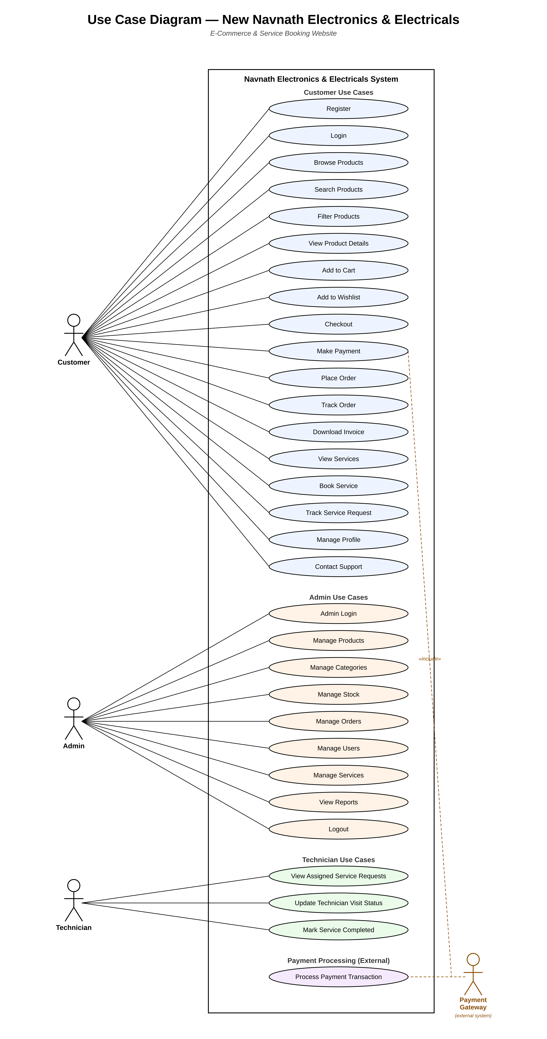

6.2 Activity Diagram
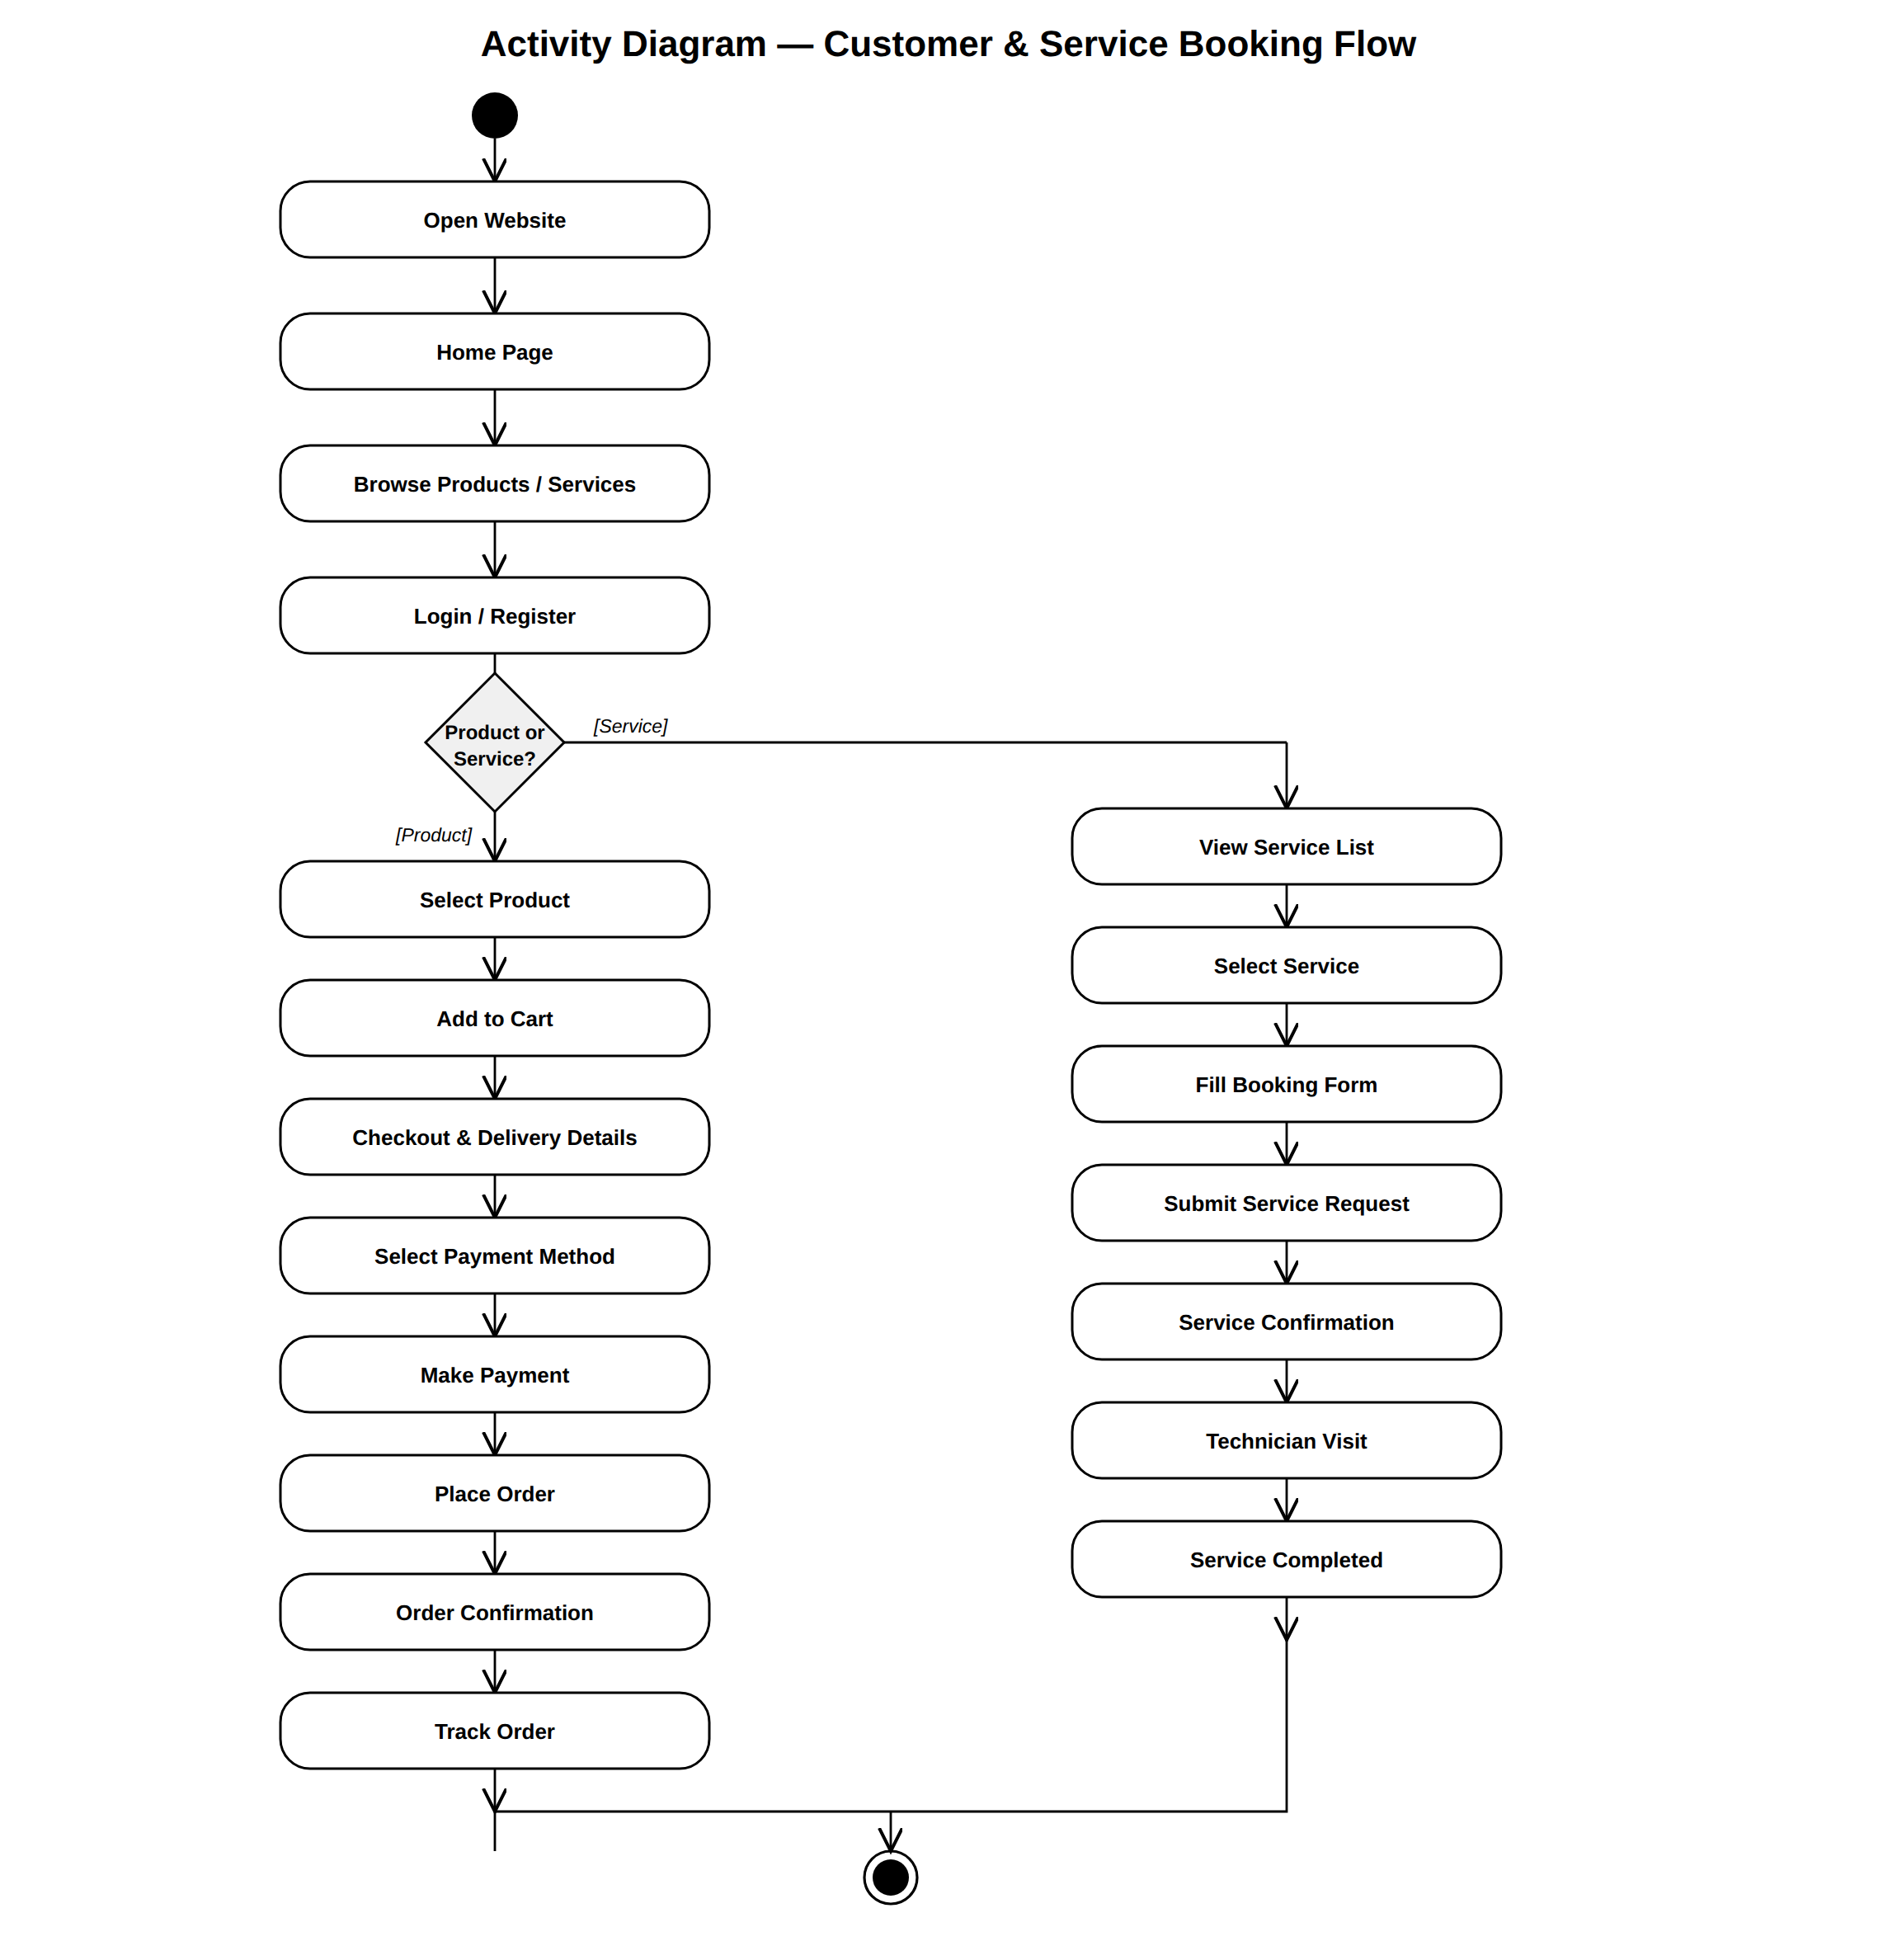

6.3 Sequence Diagram
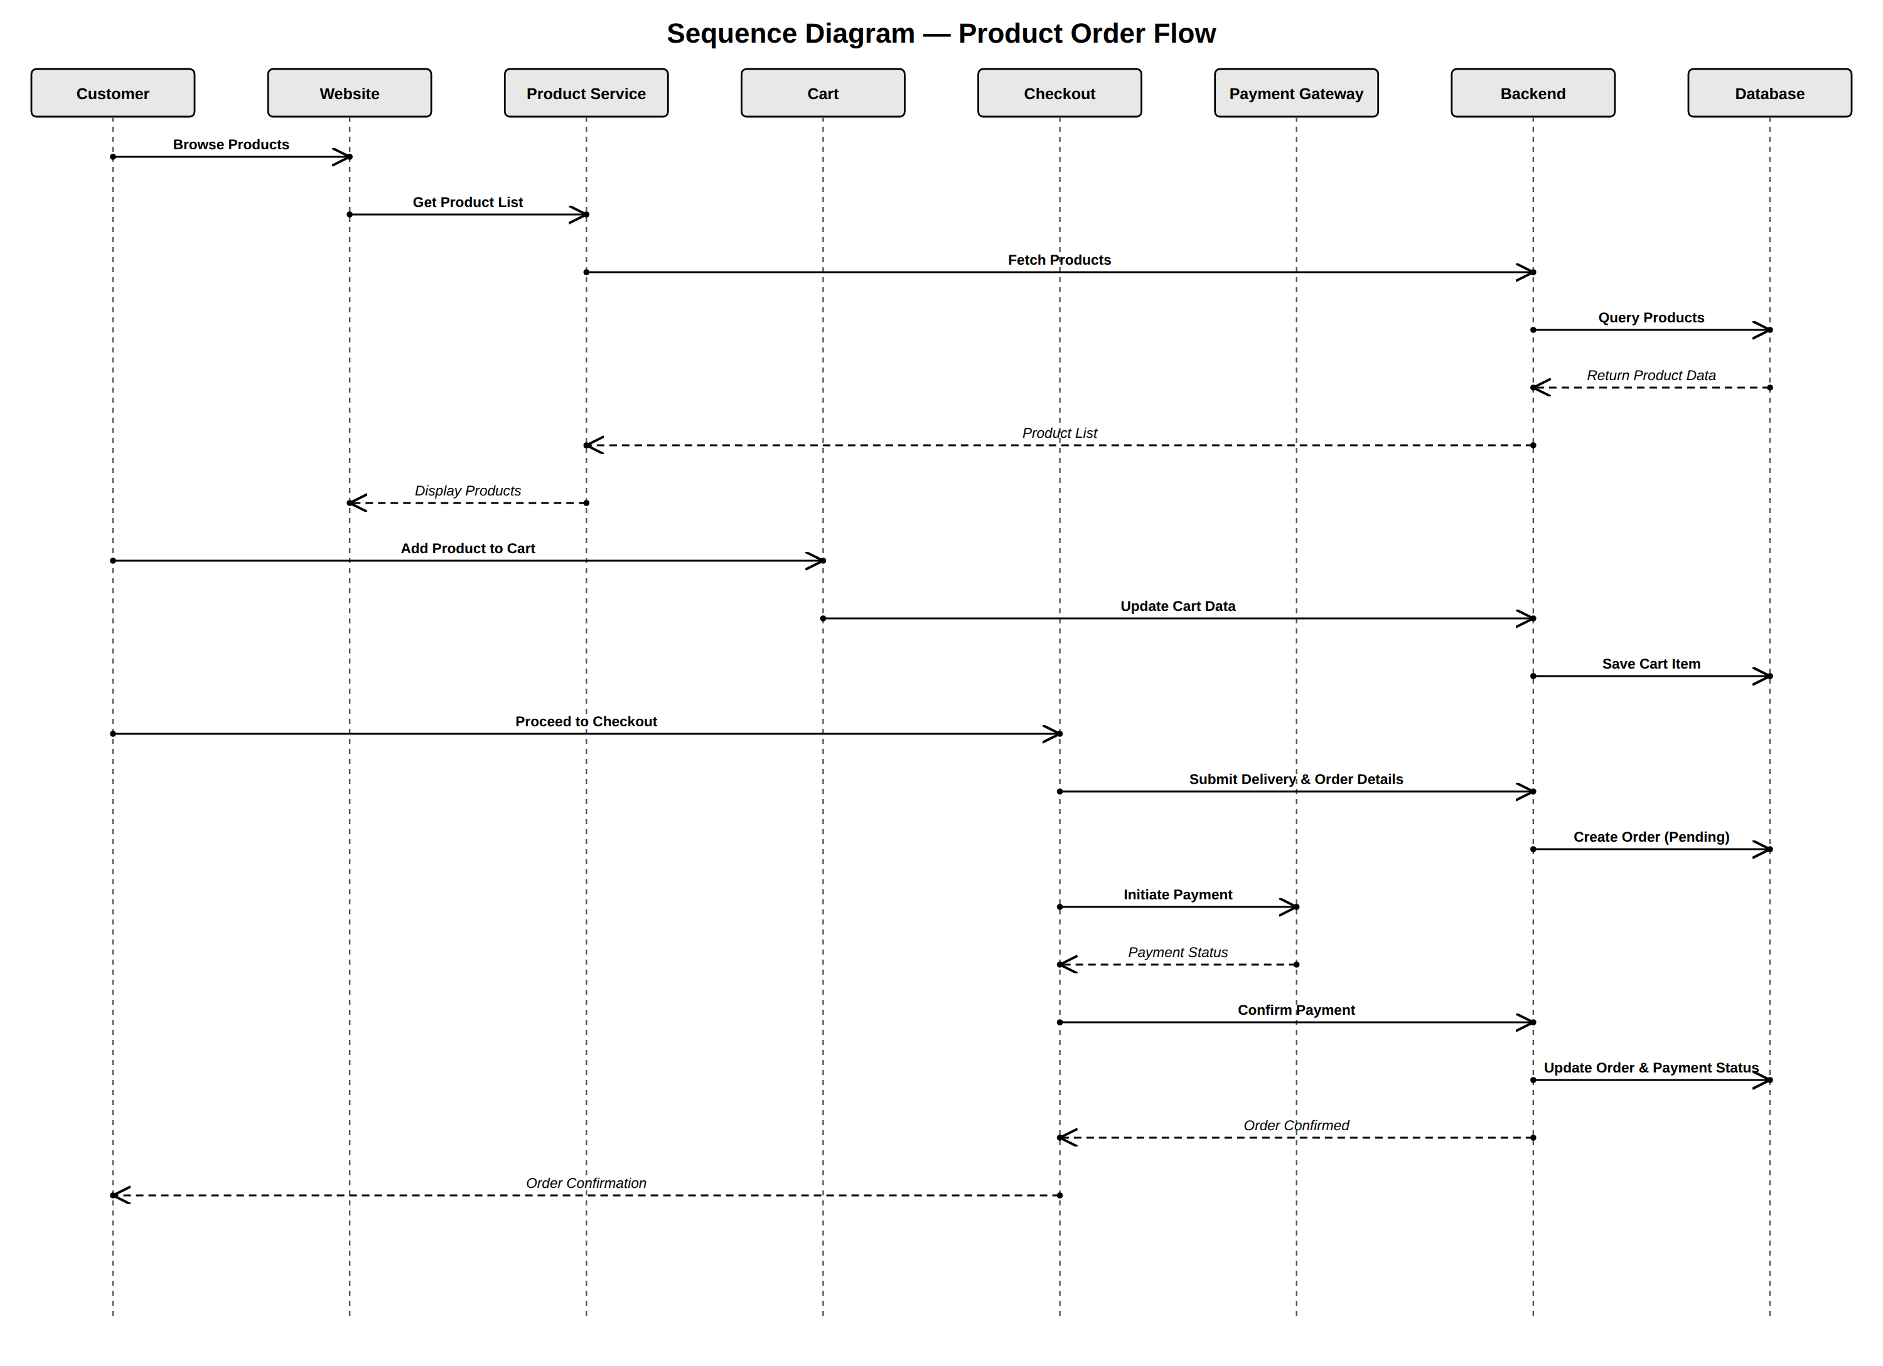

6.4 Class Diagram
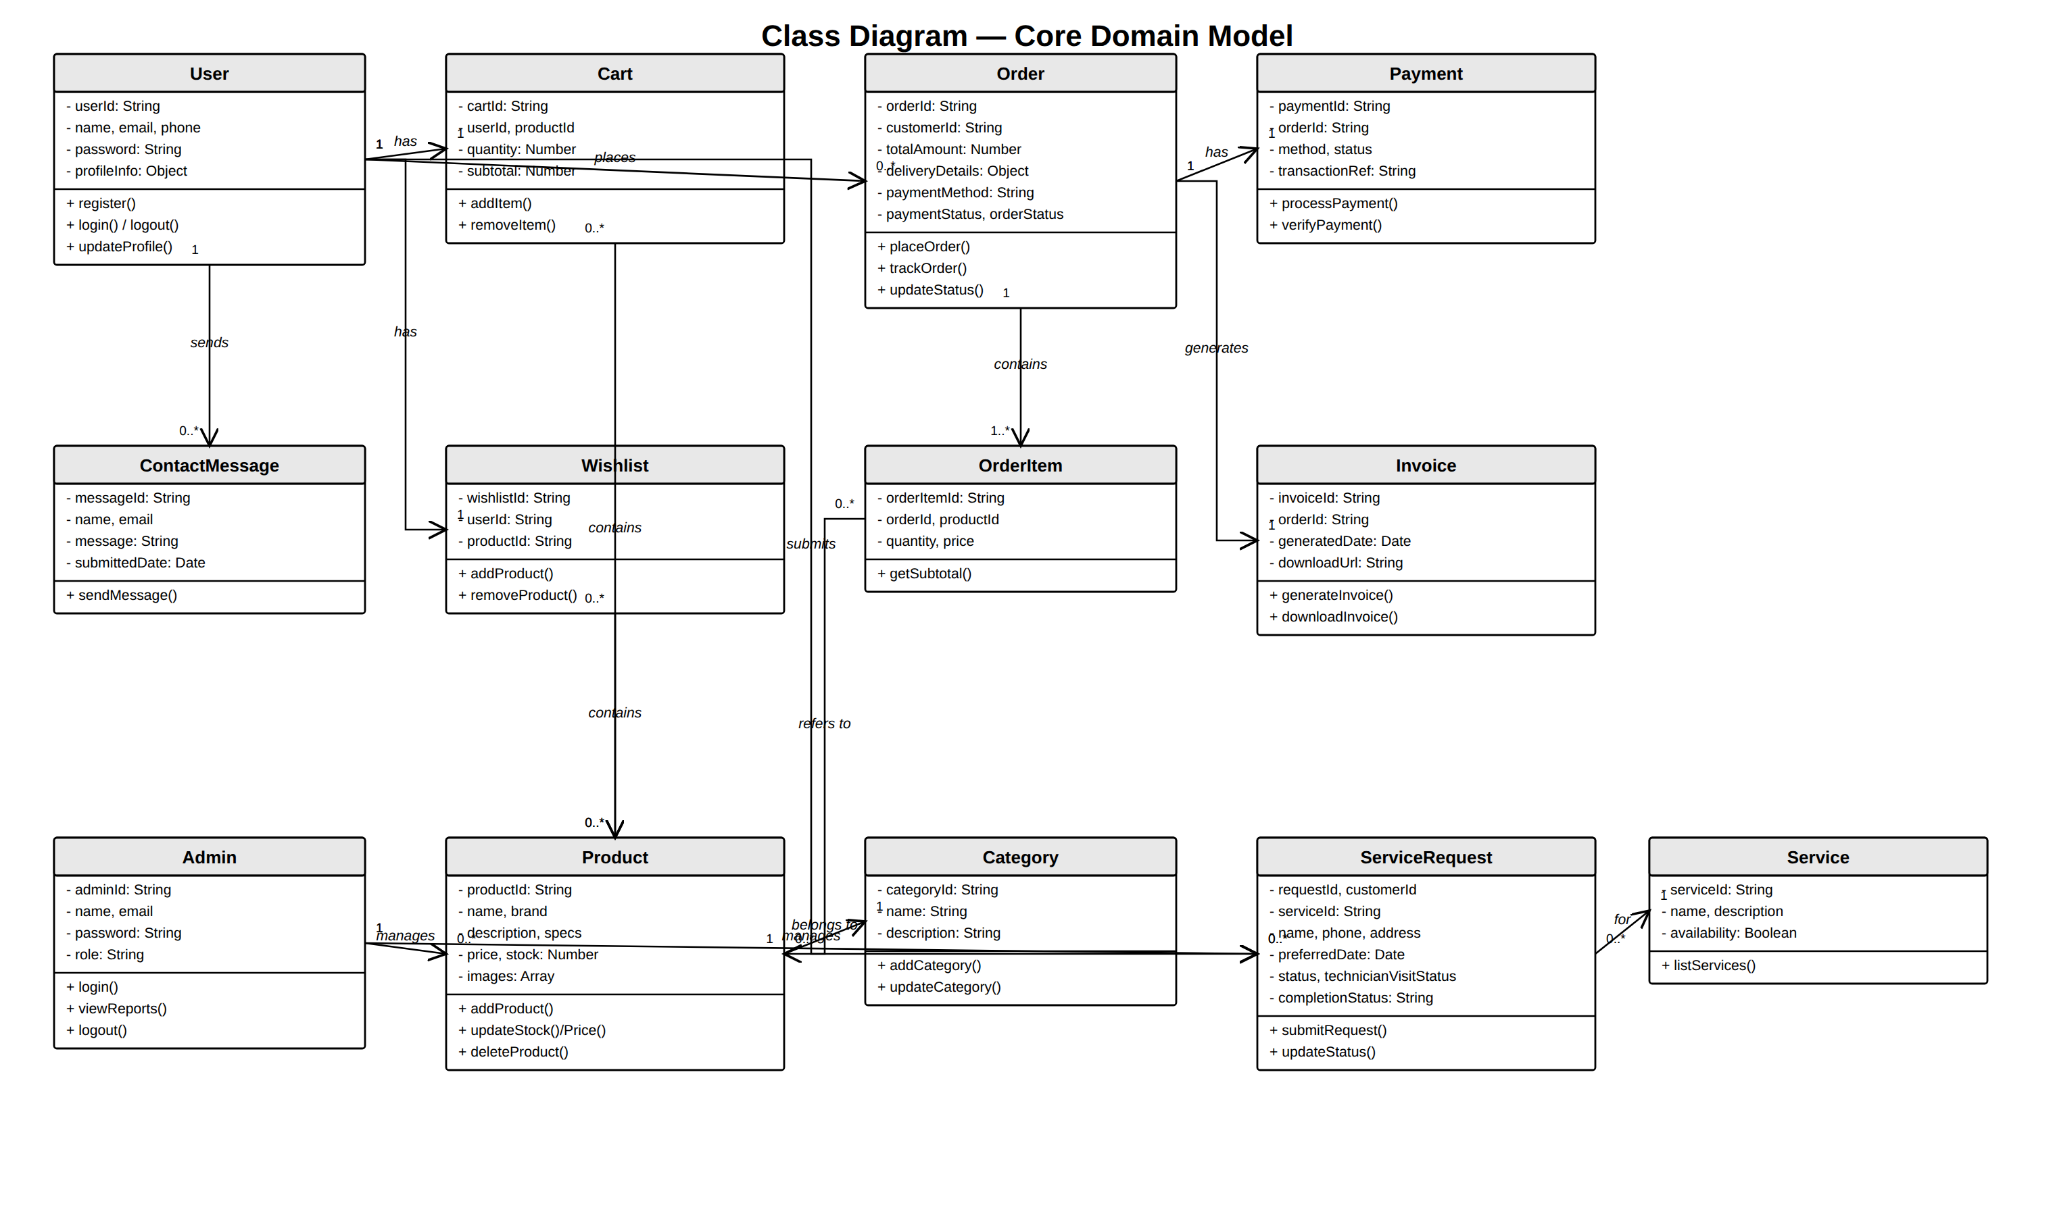

6.5 ER Diagram
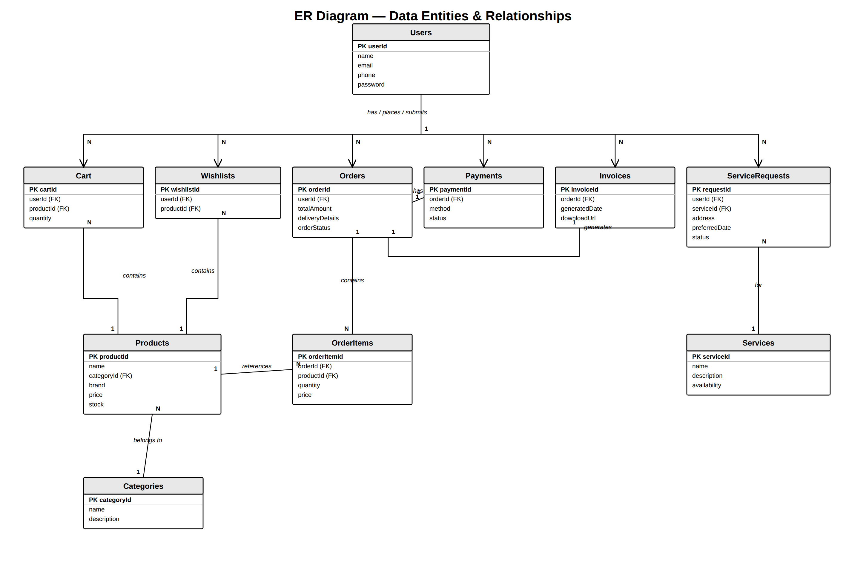

6.6 System Architecture Diagram
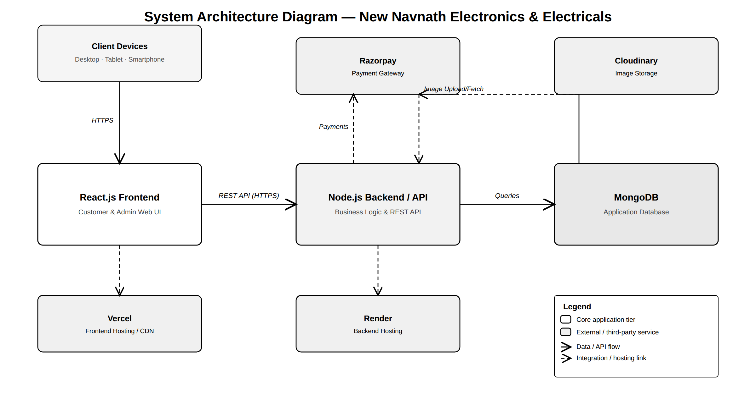

7. Data Requirements

7.1 User Data
- User ID
- Name
- Email
- Phone
- Login credentials/authentication information
- Profile information

7.2 Product Data
- Product ID
- Product name
- Category
- Brand
- Description
- Specifications
- Price
- Stock
- Product images
- Reviews where applicable

7.3 Category Data
- Category ID
- Category name
- Category description where applicable

7.4 Cart Data
- Cart ID
- User ID
- Product ID
- Quantity
- Price/subtotal

7.5 Wishlist Data
- Wishlist ID
- User ID
- Product ID

7.6 Order Data
- Order ID
- Customer ID
- Products/order items
- Quantity
- Total amount
- Delivery details
- Payment method
- Payment status
- Order status
- Invoice information

7.7 Payment Data
- Payment ID
- Order ID
- Payment method
- Payment status
- Transaction/reference information as applicable

7.8 Service Data
- Service ID
- Service name
- Service description
- Service availability

7.9 Service Request Data
- Request ID
- Customer ID
- Service ID
- Name
- Phone
- Address
- Preferred date
- Request status
- Technician visit status
- Completion status

7.10 Data Validation
The system shall validate:
- Required fields.
- Contact information.
- Login credentials.
- Product quantities.
- Order details.
- Service booking details.

8. Business Rules

BR-001: Customer Authentication
A customer must have an account/login when authentication is required for personalized features such as orders, wishlist, profile, and service requests.

BR-002: Product Availability
Products should be available for ordering according to their stock status.

BR-003: Order Creation
An order shall be created only after required checkout information is successfully provided.

BR-004: Payment
The order payment status shall correspond to the selected payment method and payment result.

BR-005: Order Status
The admin shall manage order progression through relevant processing stages such as acceptance, shipping, and delivery.

BR-006: Service Request
A service request shall contain the required customer, service, contact, address, and date information.

BR-007: Service Status
A service request can progress through confirmation, technician visit, and completion.

BR-008: Admin Authorization
Only authorized administrators shall be permitted to perform administrative operations.

BR-009: Stock Management
Product stock information shall be maintained by the administrator.

BR-010: Product Management
Only authorized administrators shall add, modify, or delete products and categories.

9. Acceptance Criteria
The system shall be considered acceptable when the following major conditions are satisfied:
ID | Acceptance Criteria
AC-001 | Customer can register successfully.
AC-002 | Registered customer can log in.
AC-003 | Customer can browse products.
AC-004 | Customer can search and filter products.
AC-005 | Customer can view product details.
AC-006 | Customer can add products to cart.
AC-007 | Customer can add products to wishlist.
AC-008 | Customer can complete checkout.
AC-009 | Customer can provide delivery details.
AC-010 | Supported payment methods can be selected and processed.
AC-011 | Customer can place an order successfully.
AC-012 | Customer receives order confirmation.
AC-013 | Customer can track an order.
AC-014 | Customer can access/download an invoice.
AC-015 | Customer can view available services.
AC-016 | Customer can submit a service booking request.
AC-017 | Customer can view service request status.
AC-018 | Customer can access contact/support options.
AC-019 | Admin can log in securely.
AC-020 | Admin can access the dashboard.
AC-021 | Admin can manage products.
AC-022 | Admin can manage categories.
AC-023 | Admin can manage stock and prices.
AC-024 | Admin can manage orders.
AC-025 | Admin can manage users/customers.
AC-026 | Admin can manage service requests.
AC-027 | Admin can view reports and analytics.
AC-028 | Admin can log out securely.
AC-029 | Website works responsively on supported screen sizes.
AC-030 | Unauthorized users cannot access protected admin functions.

10. Appendices

Appendix A – Key Features
The project workflow identifies the following key features:
- Online Ordering
- Service Booking
- User Authentication
- Admin Dashboard
- Search & Filters
- Wishlist
- Multiple Payments
- Order Tracking
- Invoice Download
- Responsive Design
- Dark Mode
- Live Support through Call/WhatsApp

Appendix B – Technology Stack
Layer | Technology
Frontend | React.js
Backend | Node.js
Database | MongoDB
Payment Gateway | Razorpay
Image Storage | Cloudinary
Deployment | Vercel / Render

Appendix C – Requirement Traceability
Feature | Requirement ID
Registration | FR-001
Login | FR-002
Product Browsing | FR-003
Search/Filter | FR-004
Product Details | FR-005
Cart | FR-006
Wishlist | FR-007
Checkout | FR-008
Delivery Details | FR-009
Payment | FR-010
Order Placement | FR-011
Order Confirmation | FR-012
Order Tracking | FR-013
Invoice | FR-014
Service Listing | FR-015
Service Booking | FR-017
Technician Visit | FR-019
Profile | FR-020
Contact/Support | FR-021
Admin Login | FR-022
Admin Dashboard | FR-023
Product Management | FR-024
Stock Management | FR-025
Category Management | FR-026
Order Management | FR-027
User Management | FR-028
Service Management | FR-029
Reports | FR-030
Admin Logout | FR-031

Appendix D – Main Workflow Summary

Customer
Visit Website → Browse Products/Services → Register/Login → Browse Products → Add to Cart → Checkout → Fill Delivery Details → Select Payment → Place Order → Order Confirmation → Track Order → Delivered

Service
View Service List → Select Service → Fill Booking Form → Submit Request → Service Confirmation → Technician Visit → Service Completed

Admin
Admin Login → Dashboard → Manage Products/Categories → Manage Orders/Users/Services → View Reports → Logout

Appendix E – Future Expansion
The system architecture can potentially be extended with additional business functionality in future versions. Any such functionality should be documented as a new requirement before implementation.

